The River Runs Through Us: Life Along the Mill River

A presentation by students in the course Public History Workshop, University of Massachusetts Amherst, in partnership with the Mill River Greenway Initiative

Historic Northampton, 46 Bridge Street, Northampton, MA
Monday, April 27, 2015, 7:30 - 9:00 PM

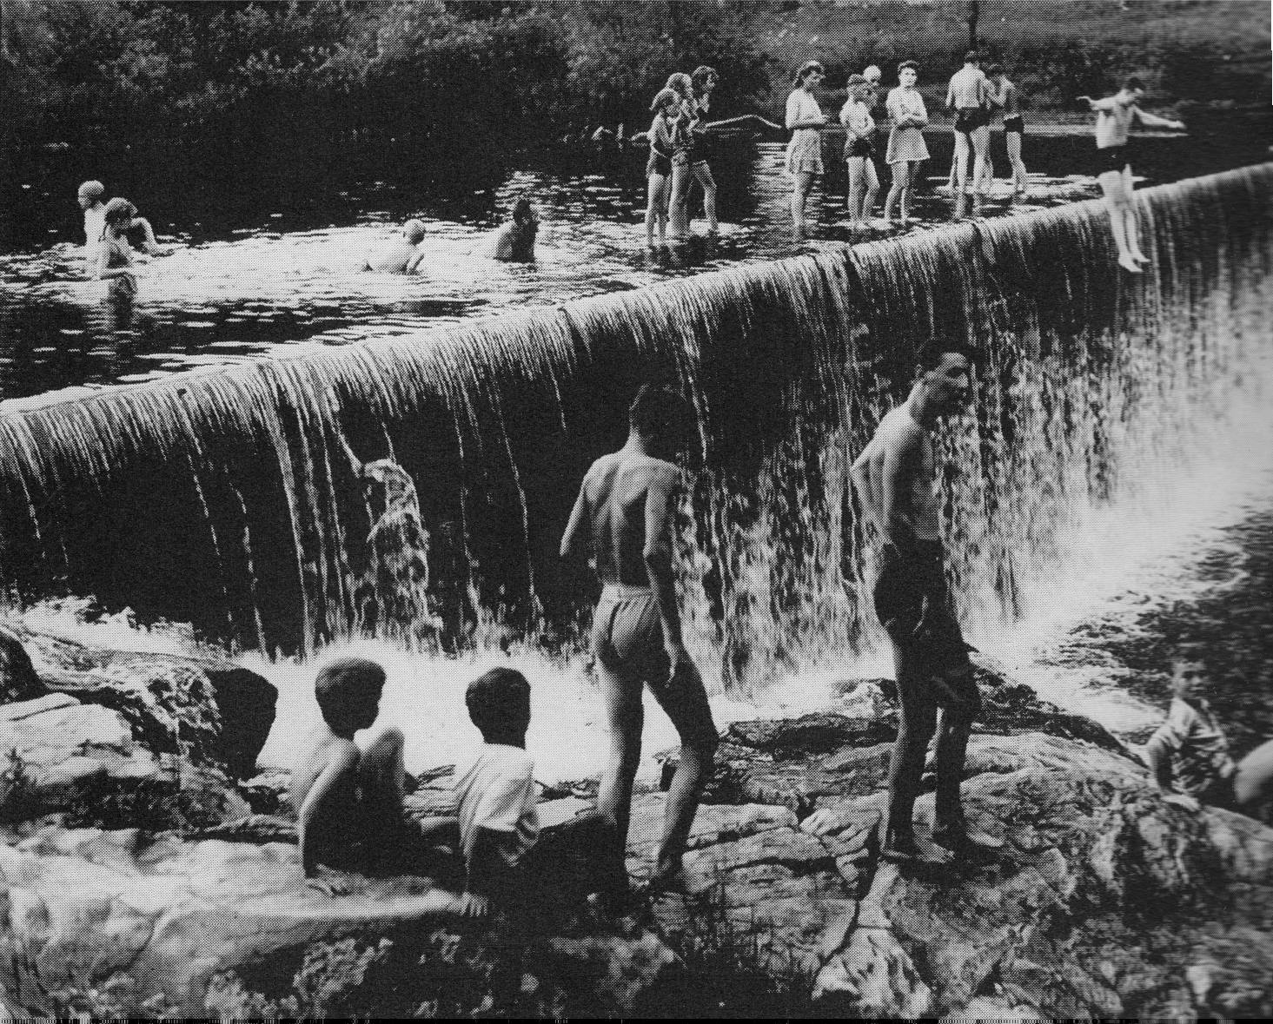

Since January 2015, a team of University of Massachusetts Amherst students has been developing a six-panel outdoor exhibit on the history of the Mill River proposed for a site near the River in Florence. The exhibit explores the history of agriculture, industry, flood control, and environmental contamination and clean-up, telling stories of the diverse peoples and dramatic events that shaped the river over the past four centuries. The students will be presenting a draft version of their project to the public for comments on Monday evening April 27 at Historic Northampton beginning at 7:30 P.M. Please come, offer your feedback, and share your ideas.



